Activity Assignment - Using Windows Form Programming C#.Net

## Insertion of Data

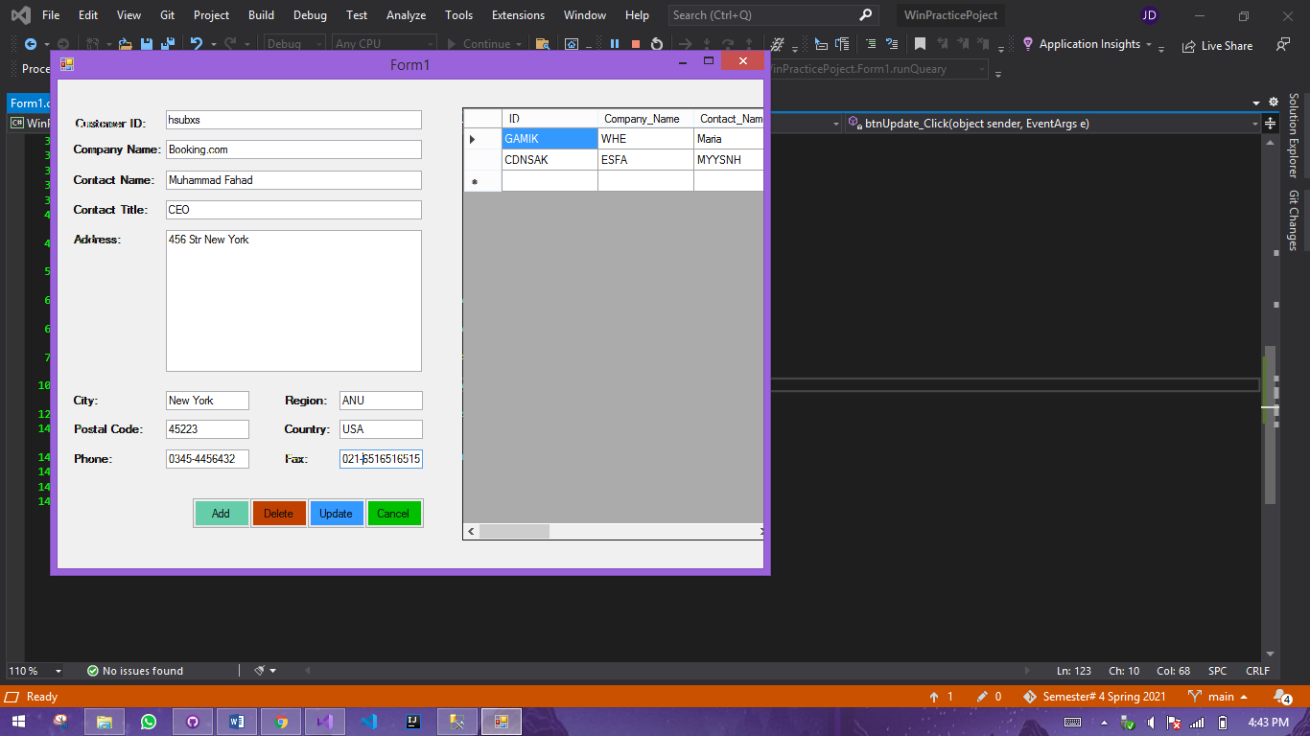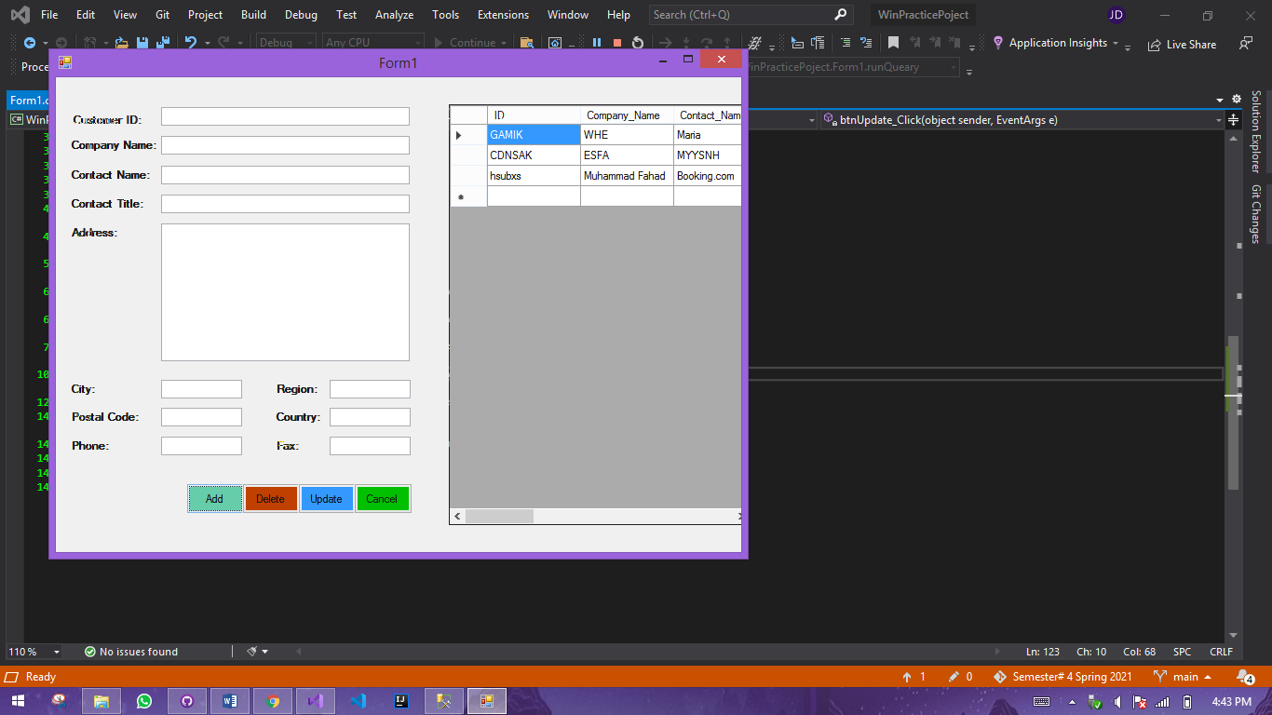

### **Code:**

private void btnAdd_Click(object sender, EventArgs e)

{

string InsertQureay = "insert into Contact values('"

+ txtID.Text +"','"+

txtCName.Text + "','" +

txtName.Text + "','" +

txtCtitle.Text + "','" +

txtAddress.Text + "','" +

txtCity.Text + "'," +

txtPostal.Text + ",'" +

txtPhone.Text + "','" +

txtRegion.Text + "','" +

txtCountry.Text + "','" +

txtFax.Text+"');";

runQueary(InsertQureay);

}

public void runQueary(string QRY)

{

// Pass Query and Connection object into the SQL Command

SqlCommand obj = new SqlCommand(QRY, con);

// Open & Close Database after execute the query

con.Open();

obj.ExecuteNonQuery();

con.Close();

getData();

}

## Delete from Database

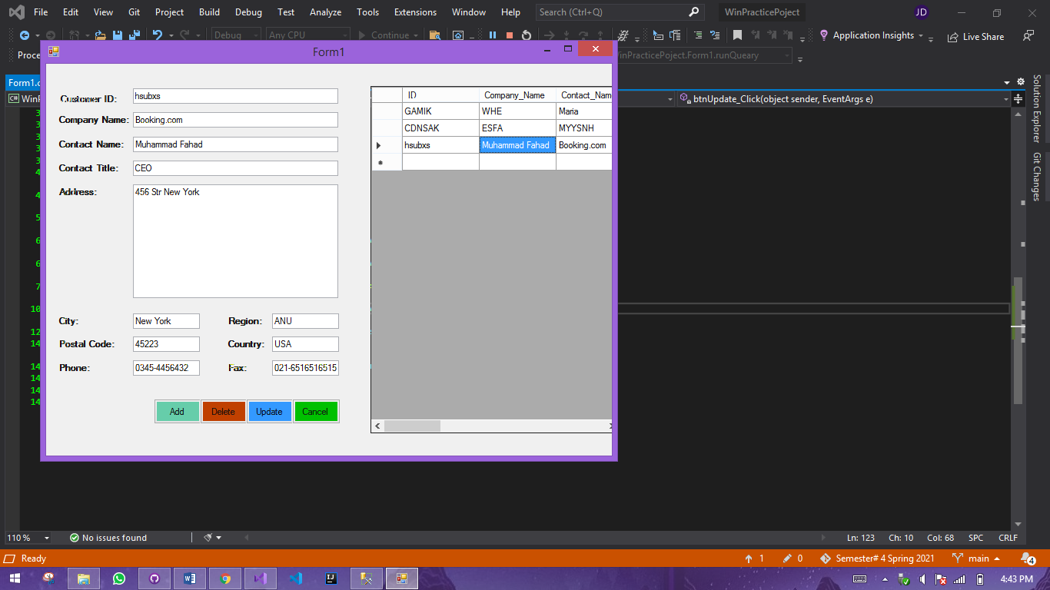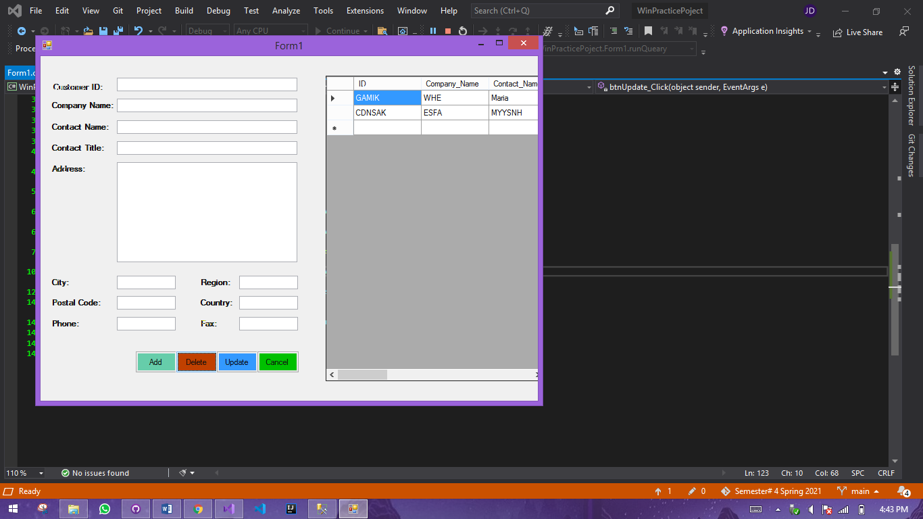

### Code

private void btnDelete_Click(object sender, EventArgs e)

{

if (ID != "")

{

runQueary("DELETE FROM Contact WHERE Id = '" + txtID.Text + "';");

ID = "";

}

}

## Update into Database:

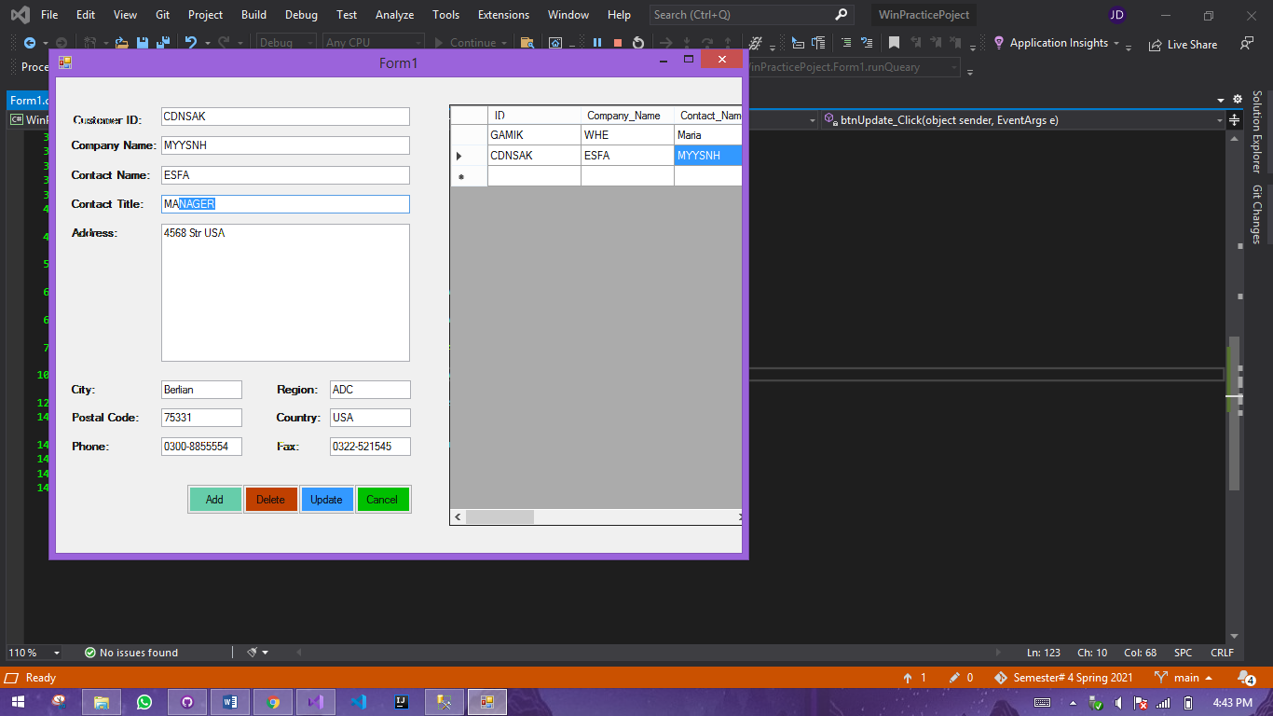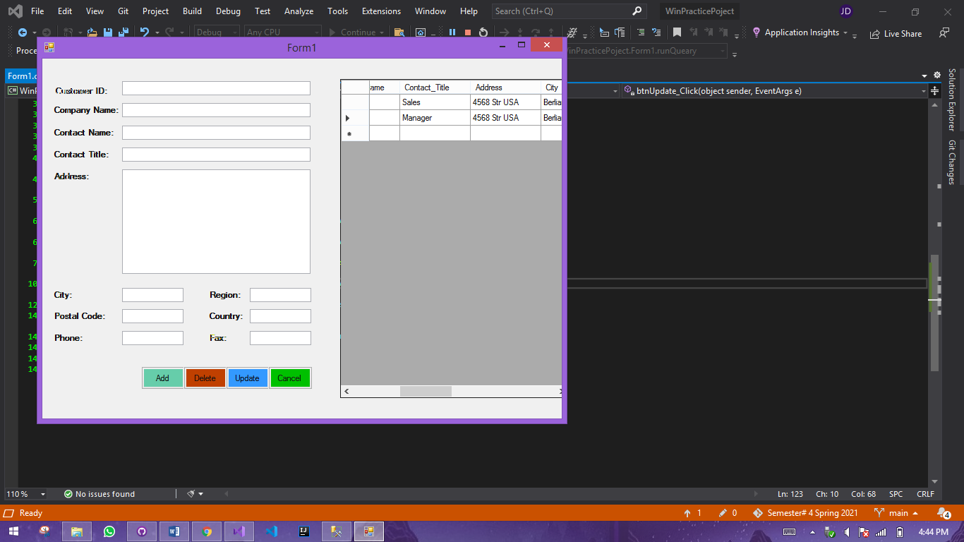

### Code

public void runQueary(string QRY)

{

// Pass Query and Connection object into the SQL Command

SqlCommand obj = new SqlCommand(QRY, con);

// Open & Close Database after execute the query

con.Open();

obj.ExecuteNonQuery();

con.Close();

getData();

}

public void getData()

{

SqlDataAdapter da = new SqlDataAdapter("Select * from Contact", con);

DataSet ds = new DataSet();

da.Fill(ds);

DataDisplay.DataSource = ds.Tables[0];

Clear();

}

public void Clear()

{

txtID.Text = "";

txtCName.Text = "";

txtName.Text = "";

txtCtitle.Text = "";

txtAddress.Text = "";

txtCity.Text = "";

txtPostal.Text = "";

txtPhone.Text = "";

txtRegion.Text = "";

txtCountry.Text = "";

txtFax.Text = "";

}

private void btnCancel_Click(object sender, EventArgs e)

{

Clear();

}

private void btnDelete_Click(object sender, EventArgs e)

{

if (ID != "")

{

runQueary("DELETE FROM Contact WHERE Id = '" + txtID.Text + "';");

ID = "";

}

}

private void DataDisplay_CellContentClick(object sender, DataGridViewCellEventArgs e)

{

int index = e.RowIndex;

ID = DataDisplay.Rows[index].Cells[0].Value.ToString();

txtID.Text = DataDisplay.Rows[index].Cells[0].Value.ToString();

txtCName.Text = DataDisplay.Rows[index].Cells[1].Value.ToString();

txtName.Text = DataDisplay.Rows[index].Cells[2].Value.ToString();

txtCtitle.Text = DataDisplay.Rows[index].Cells[3].Value.ToString();

txtAddress.Text = DataDisplay.Rows[index].Cells[4].Value.ToString();

txtCity.Text = DataDisplay.Rows[index].Cells[5].Value.ToString();

txtPostal.Text = DataDisplay.Rows[index].Cells[6].Value.ToString();

txtPhone.Text = DataDisplay.Rows[index].Cells[7].Value.ToString();

txtRegion.Text = DataDisplay.Rows[index].Cells[8].Value.ToString();

txtCountry.Text = DataDisplay.Rows[index].Cells[9].Value.ToString();

txtFax.Text = DataDisplay.Rows[index].Cells[10].Value.ToString();

}

private void btnUpdate_Click(object sender, EventArgs e)

{

if (ID != "")

{

string UpdateQureay = "UPDATE Contact SET " +

"Company_Name = '" + txtCName.Text + "'," +

"Contact_Name = '" + txtName.Text + "'," +

"Contact_Title = '" + txtCtitle.Text + "'," +

"Address = '" + txtAddress.Text + "'," +

"City = '" + txtCity.Text + "'," +

"Postal_Code = " + txtPostal.Text + "," +

"Phone = '" + txtPhone.Text + "'," +

"Region = '" + txtRegion.Text + "'," +

"Country = '" + txtCountry.Text + "'," +

"Fax = '" + txtFax.Text +

"' WHERE Id = '" + txtID.Text + "' ;";

runQueary(UpdateQureay);

}

}

private void btnAdd_Click(object sender, EventArgs e)

{

string InsertQureay = "insert into Contact values('"

+ txtID.Text +"','"+

txtCName.Text + "','" +

txtName.Text + "','" +

txtCtitle.Text + "','" +

txtAddress.Text + "','" +

txtCity.Text + "'," +

txtPostal.Text + ",'" +

txtPhone.Text + "','" +

txtRegion.Text + "','" +

txtCountry.Text + "','" +

txtFax.Text+"');";

runQueary(InsertQureay);

}